**LIBRARY MANAGEMENT SYSTEM**

**Project Overview**

Library Management System is a console based application.This java based project primarily focuses on basic library activities including adding book,updating books,deleting book,viewing books.This system begins with registration and moves through library management system to administration.This system provides separate user and administrator logins.Users can use this system, which contains a list of all books from anywhere in the campus but they must first register.Users can view the book and they can borrow books which they need.In this System’s administrator can keep track of the entire procedure.

**Scope of project:**

**In Scope**

Following are the key features that needs to be implemented for Admin and User.

**Admin**

1. Login
2. Add Book
3. View Book
4. Update Book
5. Delete Book
6. View User
7. Delete User
8. View Borrow Book
9. Delete Borrow Book

User

1. Register
2. Login
3. View Book
4. Update User Details
5. Add Borrow Book

**DB Schema**

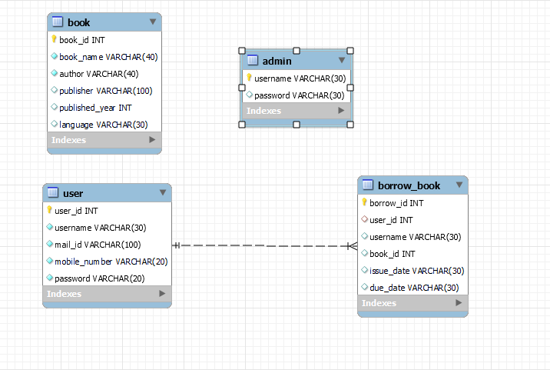

**Use Cases:**

There will be two types of users will be using this application

1. Admin
2. User

**Key Responsibilities:**

* **Admin -** Responsible for managing book details in the Library Management System.
* **User -** Find the books in the library and they can borrow book.

**Admin Scope:**

Admin should login with their credentials.

Admin page has menu of options.

**Admin Login**

Admin can login by providing the following user credentials.

1. Username
2. Password

**Admin Add Book**

Admin can add new Books into library Management System.

**Admin View Book**

List of Books shown to the admin with the following details about each book.

1. Book Id
2. Book Name
3. Author
4. Publisher
5. Published Year
6. Language

**Admin Update Book**

Admin can update the details based on their requirements.

**Admin Delete Book**

Based on Book Id, admin can delete the book from Library Management System.

**Admin View Users**

Admin can view the details of those who have been registered.

List of Users are shown to the admin with the following details.

1. User Id

2.Username

3.Mail Id

4.Mobile Number

5.Password

**Admin Delete User**

Based on User Id,admin can delete the users.

**Admin View Borrow Book**

Admin can view the details of borrow book and the following details are shown to the admin.

1. Borrow Id
2. User Id
3. Username
4. Book Id
5. Issue Date
6. Due date

**Admin Delete Borrow Book**

Based on User Id the admin can delete the borrow book details.

**User Scope:**

User should login with their credentials.

User page has menu of options.

**User Login**

User can login by providing the following user credentials.

1. Username
2. Password

**User Register**

Users should register with the required details.

1. User Id
2. Username
3. Mail Id
4. Mobile Number
5. Password

**User View Book**

After logged in,User have the option to view all the book details.

**User Update Details**

User can update the details based on their needs.

**User Add Borrow Book**

User can borrow book based on their requirements and return the book before the due date.